**Assignment 5**

**Due, Wednesday, July 5, 2017 for maximum 100**

**Thursday, July 6, 2017 for maximum 90**

**Friday, July 7, 2017 for maximum 80**

**Saturday, July 8, 2017 for maximum 70**

**Assignment Scope**

1. Using the Timer class
2. Using the DefaultStyle Document class
3. Writing Action or Item Listeners
4. Formatting data

**Deliverables**

To complete this assignment you must submit your **compressed Netbeans project** to Webcourses.

**Tasks and Rubric**

|  |  |  |
| --- | --- | --- |
| Activity | | |
| userInterface package |  |
| BoggleUi.java |  |
|  | 1. Add member variables    1. Of type class javax.swing.Timer    2. Primitive data type int for the minutes    3. Primitive data type int for the seconds    4. Of the inner class implementing interface ActionListener for resetting the game board |
|  | 1. Update the custom constructor to instantiate the member variable of the inner class that implements interface ActionListener for resetting the game board |
|  | 1. Update method initComponents() to    1. Add letters to the JButtons for the dice by calling the setText() method on class JButton passing as an argument each of the letters generated by method shakeDice()    2. Register the inner class that implements interface ActionListener for resetting the game board to member variables       1. JMenuItem for New Game       2. JButton for shake dice    3. Instantiate the member variable of type Timer       1. Pass as an argument to the constructor 1 second represented in milliseconds       2. An instance of the inner class that implements interface ActionListener that manages the timer       3. Start the timer |
|  | 1. Write an inner class to create an ActionListener that is registered to the JMenuItem with the text Exit; it should    1. Display a JOptionPane message confirming the user wants to exit using method showConfirmDialog()    2. If yes, exit the application by calling method System.exit() passing the value of 0 as an argument    3. If no, do not exit the application |
|  | 1. Write an inner class to create an ActionListener that is registered to the JMenuItem with the text New Game and the Shake Dice button; it should    1. Call method shakeDice() on the reference object of class Board to get new letters for the dice    2. Populate the dice using method setText() on each JButton to set the letters visually on the JButton    3. Clear the text in the JTextPane by calling method setText() and passing an explicit empty string    4. Clear the text in the score JLabel by calling method setText() and passing an explicit value of 0    5. Clear the text in the current word JLabel by calling method setText() and passing an explicit empty string    6. Reset the time left JLabel by calling method setText() and passing an explicit string of 3:00    7. Call method revalidate() on the JFrame reference object    8. Call method repaint() on the JFrame reference object    9. Reset the timer by       1. Calling method stop()       2. Resetting the value of minutes to 3       3. Resetting the value of seconds to 0       4. Calling method start() |
|  | 1. Write an inner class that creates an ActionListener that is passed as an argument to the instance of class Timer; it should    1. Check if the minutes and seconds are equal to 0, if yes, then call the stop() method on the member variable of class Timer    2. Check if the seconds are equal to 0, if yes, reset the seconds to 59 and decrement the minutes by 1    3. Decrements the seconds by 1    4. Check if the seconds are less than 10, if yes, then concatenate an explicit 0 to the remaining seconds    5. Update the text on the JLabel for time left by calling method setText() |
| Boggle application |  |
| Test Case 1 | Test Case 1 passes |
| Test Case 2 | Test Case 2 passes |
| Test Case 3 | Test Case 3 passes |
| Test Case 4 | Test Case 4 passes |
| Test Case 5 | Test Case 5 passes |
|  | Source compiles with no errors |
|  | Source runs with no errors |
|  | Source includes comments |
| Total |  |

**Perform the following test cases**

|  |  |  |
| --- | --- | --- |
| Test Cases | | |
|  | **Action** | **Expected outcome** |
| Test Case 1 | **User interface display** | User interface is similar to figure 1 with letters on the JButtons |
| Test Case 2 | **User interface display** | User interface is similar to figure 1 with the time in the Time Left JLabel counting down when the game starts |
| Test Case 3 | **User interface display** | JLabel for time should looks similar to figure 2 when the seconds are less than the value of 10 |
| Test Case 4 | **User interface display** | When the user clicks on the Shake Dice JButton the user interface should display different letters than before |
| Test case 5 | **Exit program** | When the user selects the Exit option from the Boggle menu the user should be presented with a JOptionPane message in figure 3; if the user selects Yes, the application should shutdown |

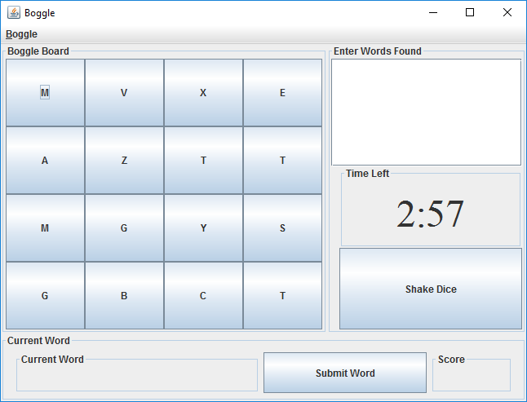

Figure 1 User Interface Display

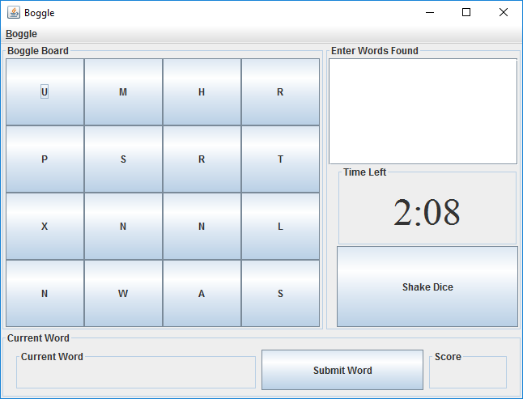

Figure 2 Formatted time

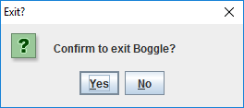

Figure 3 Confirm Exit